Abhishek Ojha

Seat No 027

practical no 4

CRUD Operations on Types

**Practical No : 4**

**Aim:** Create different types that include attributes and methods. Define tables for these types by adding sufficient number of tuples. Demonstrate insert, update and delete operations on these tables. Execute queries on them.

**Software Requirement:**

Oracle 11g.

**Steps:**

1. AddrType1 (PinQuery: number, Street :char, City : char, state :char) .
2. BranchType (address: AddrType1, phone1: integer,phone2: integer).
3. AuthorType (name:char,,addr AddrType1).
4. PublisherType (name: char, addr: AddrType1, branches: BranchTableType.
5. books(title: varchar, year : date, published_by ref PublisherType,authorsAuthorListType).
6. Insert some records into the above tables and fire the following queries.

**Query:**

1. List all of the authors that have the same pin Query as their publisher.
2. List all books that have 2 or more authors.
3. List the name of the publisher that has the most branches.
4. List all authors who have published more than one Book.

### List all books (title) where the same author appears more than once on the list of authors (assuming that an integrity constraint requiring that the name of an author is unique in a list of authors has not been specified).

**Practical Implementation Steps :**

* **Step 1:-** AddrType1 (PinQuery: number, Street :char, City : char, state :char).

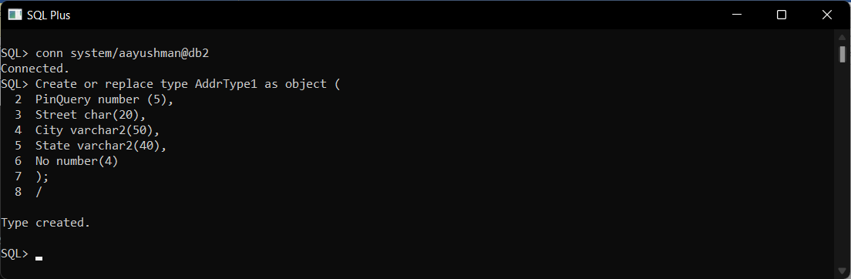

* **Step 2:-** BranchType (address: AddrType1, phone1: integer,phone2: integer).

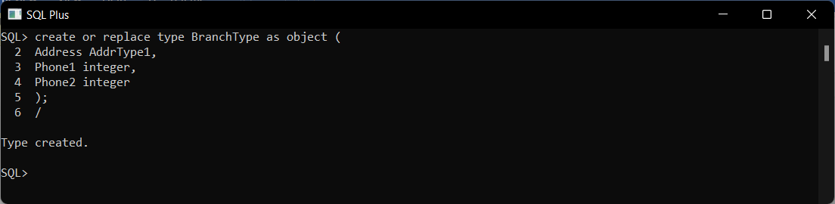

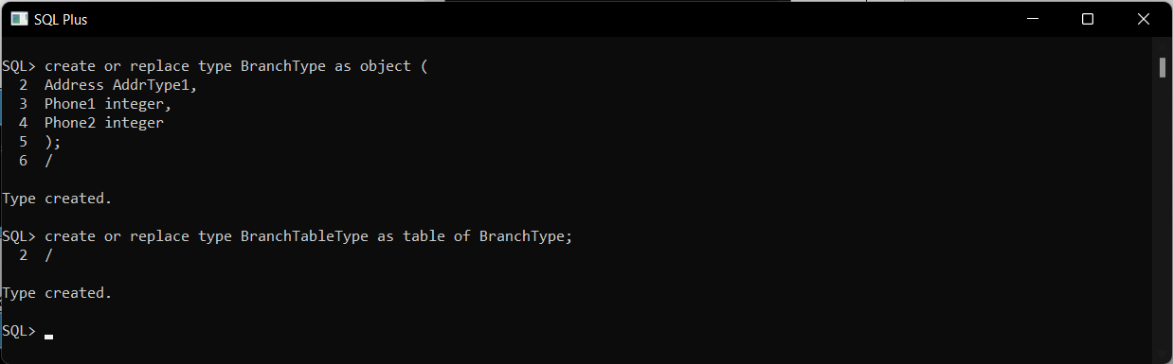

* **Step 3:-** AuthorType (name:char,,addr AddrType1).

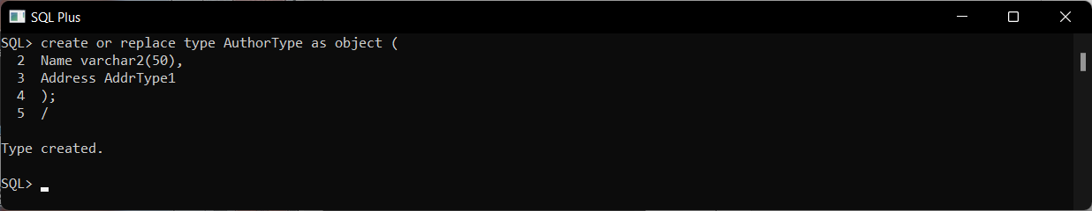

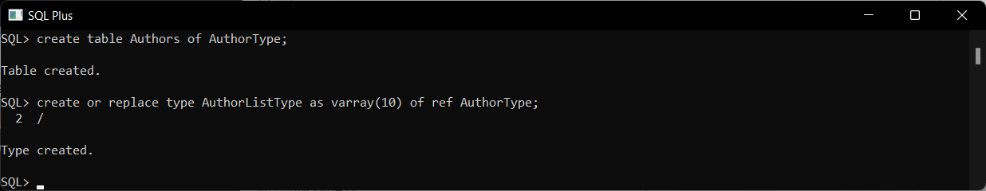

* **Step 4:-** PublisherType (name: char, addr: AddrType1, branches: BranchTableType.

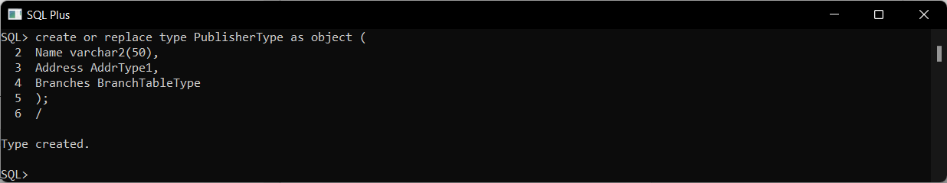

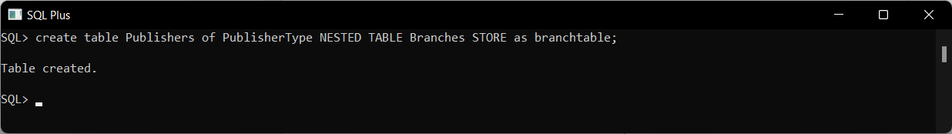

* **Steps 5**:- books(title: varchar, year : date, published_by ref PublisherType,authorsAuthorListType).

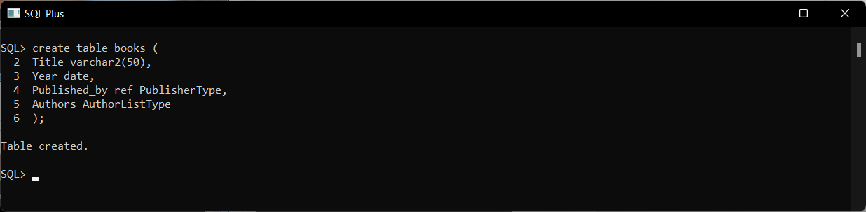

* **Step 6:-** Insert some records into the above tables and fire the following queries.

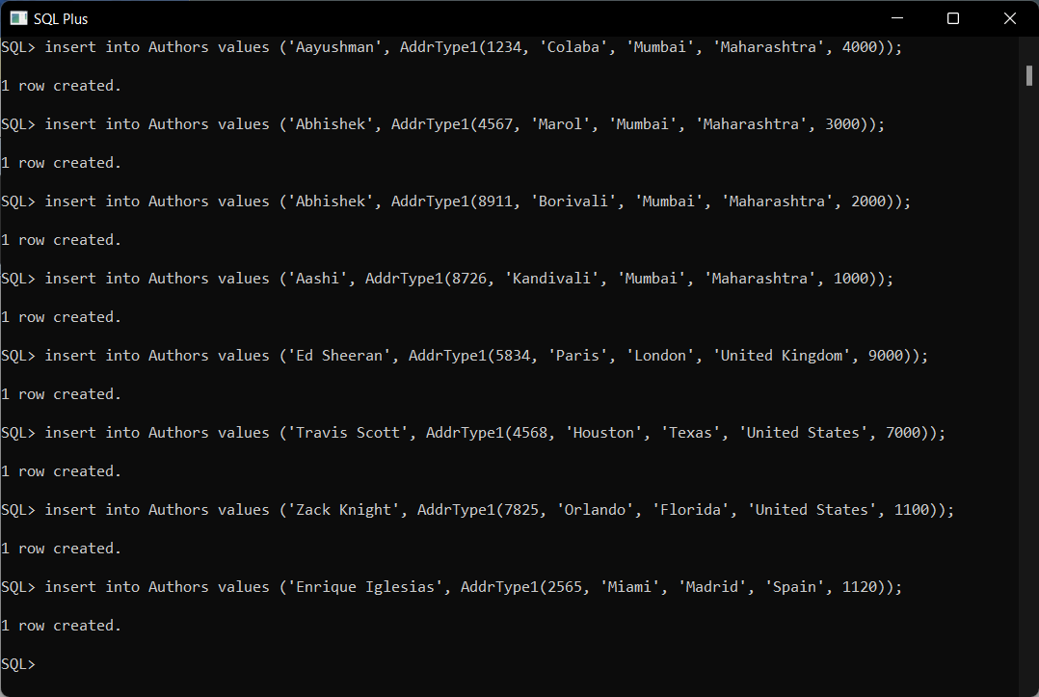

**Step 7: -** Insert Some records into the above tables and fire the following queries.

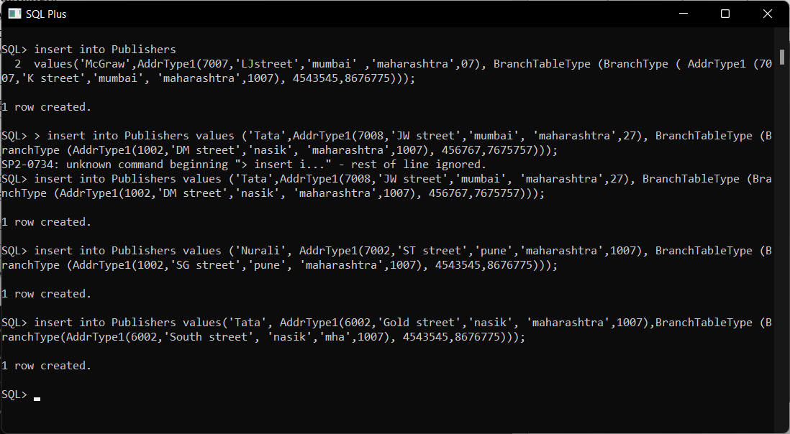

**Step 8:-** Insert some records into the above tables and fire the following queries

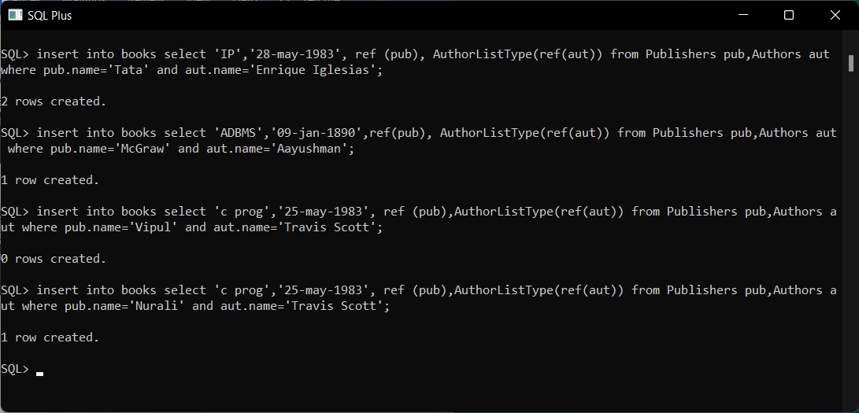

**Query : List all of the authors that have the same pin Query as their publisher.**

**select a.name from Authors a, Publishers p**

**where a.Address.pinQuery = p.Address.pinQuery;**

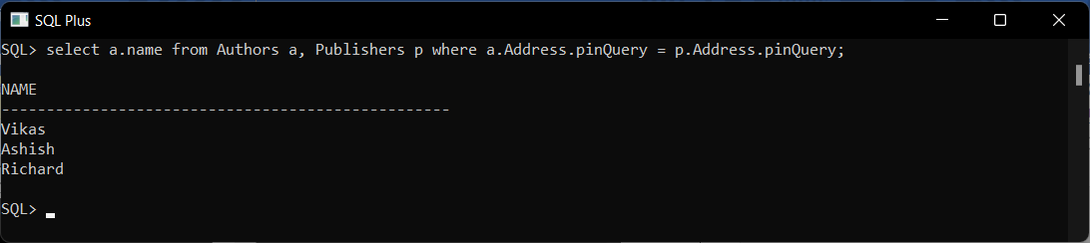

**Query: List all books that have 2 or more authors**

**Select title from books b where 1 <= (select count(*) from table(b.authors));**

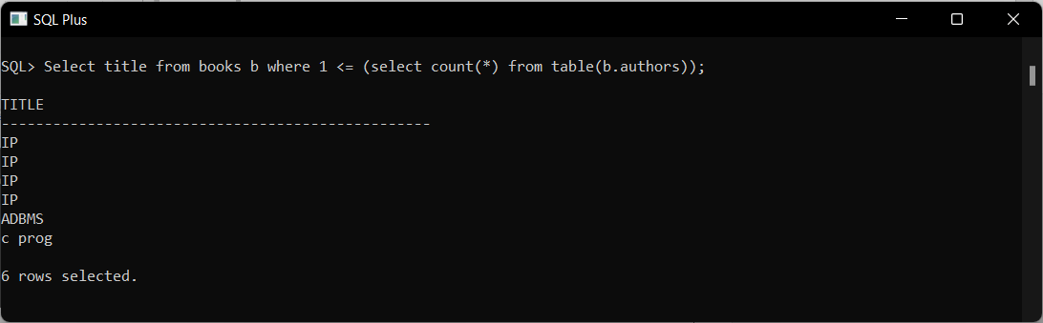

**Query: List the name of the publisher that has the most branches**

**Select p.name from publishers p, table (p.branches) group by p.name having count(*)> = all (select count(*)from publishers p, table(p.branches) group by name);**

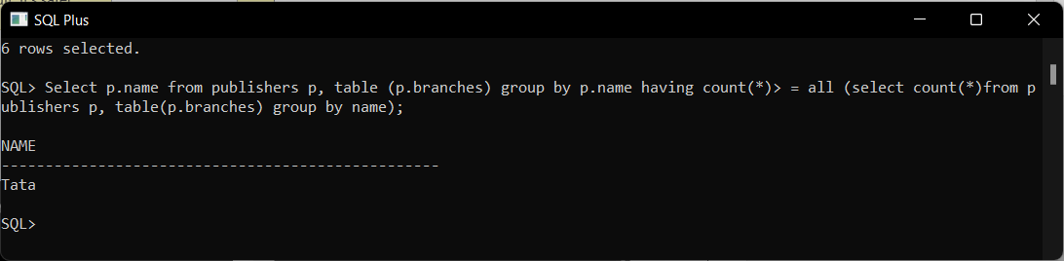

**Query: List all authors who have published more than one Book**

**select a.name from authors a, books b, table (b.authors) v**

**where v.column_value = ref(a) group by a.name having count(*) > 1;**

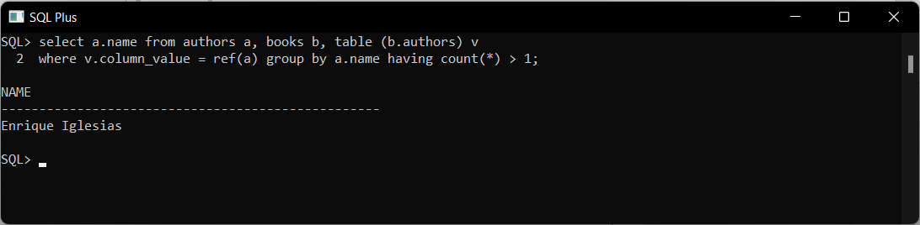

### Query: List all books (title) where the same author appears more than once on the list of authors (assuming that an integrity constraint requiring that the name of an author is unique in a list of authors has not been specified).

**select title from authors a, books b, table (b.authors) v wherev.column_value = ref(a) group by title having count(*) > 1;**

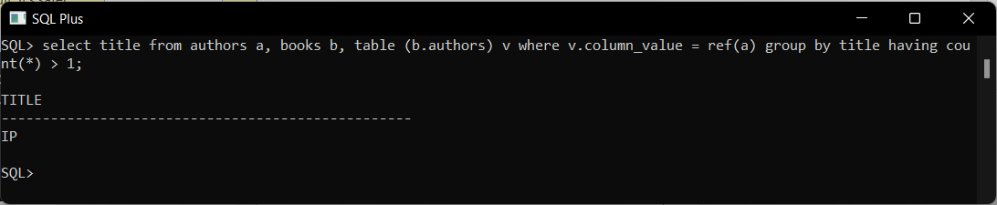

**Conclusion :** Successfully Demonstrated insert, update and delete operations on Type